1. Venue: Sports Hall, Epsom College, Longdown Lane, Epsom, KT17 4JQ.
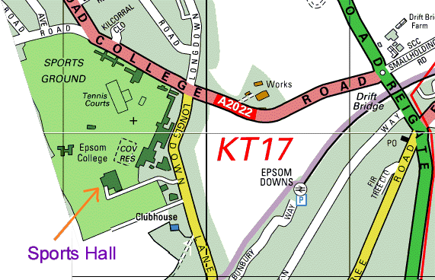
2. Report By Times (these are “close of report” times):
U10 U12 U14 U16 U18 Boys Foil 9.30am
U10 U12 U14 U16 U18 Girls Foil 9.30am (The organiser may combine some categories)
U12 U14 U16 U18 Boys and Girls Epee 1.00pm (The organiser may combine some categories)
U12 U14 U16 U18 Mixed Sabre 2.30pm (separate boys and girls events only if entries allow).
3. BFA Cards: Bring your British Fencing Association membership card with you.
4. Please note all foil and epee events will be electric. Sabre will be electric wherever enough fencers have equipment.
5. Referee: If your club can bring a referee, this will help the smooth running of the competition. If clubs wish to reserve a coach for coaching / supervising then please bring additional referees as well.
6. Electric apparatus: Would clubs please send a box if possible (we will rely on this, please notify organiser how many sets you can bring).
7. Kit: You must bring your kit in good working order and in a safe condition. The organiser reserves the right to refuse to allow a fencer to compete in kit he considers to be unsafe. Plastrons are mandatory. Breeches are recommended but safe trousers for U10, U12 and U14 may be allowed at organisers discretion.
7. The age dateline is 1st Jan 2006. For example, if you were born in 1992 or 1993 then you will fence in the U14 group. If you were born in 1988 or 1989 then you will fence in the U18 group.
9. Blade size restrictions: U12 and U14: Foil size 3, sabre 2, epee 2. Over 14 may use size 5.
10. Please do bring you own provisions but do not consume or spill sticky drinks in the sports hall. Your entry fee does not include cleaning of the sports hall; we are relying on no one spilling any food or drink.
11. Disclaimer: All fencers are reminded that they compete at their own risk. The organisers will take all reasonable care, but do not accept liability for loss or injury, howsoever caused. A parent or guardian must sign the entry form. If you object to photography then consult the organiser.
12. Any changes or announcements will be posted at www.scfu.homestead.com

I hope we will have a great day of fencing.

Yours,
Ian de Whalley on behalf of Chris Howser
SCFU Secretary Competition Organiser

Entry Form
Please print clearly:
1. Name ………………………………………….……………….……..……...……….
2. Male / Female (delete as applicable).
3. Foil / Epee / Sabre (delete as applicable).
4. Club …………………………………………………………….….…….….………
5. Email (optional) …………………………………………………….………….….…….…..
6. Address (only needed if no email) ……………………………….……….………………..….
………………………………………………………….…….…….….………
7. Phone 1 (only if no email) ………………………………………….……………..………….
8. Phone 2 (on the day emergency number) ……………………….……………………...…..….
9. BFA Membership Number. ………………… Expires ……………..…………………
10. Date of birth ………………………………
The age dateline is 1st Jan 2006. For example, if you were born in 1992 or 1993 then you will fence in the U14 group. If you were born in 1988 or 1989 then you will fence in the U18 group.
11. U12 / U14 / U16 / U18 (delete as applicable).
12. Seeding Information. Please state your previous best results. List best results first. If this is your first competition then please state for how long you have been fencing.

Year | Event | Position

13. Signature of parent /guardian …………………………………..…………..
14. Payment: Cheque for £6.00/event payable “S.C.F.U.”
Please post to Chris Howser, 47 Nutfield Rd, Merstham, Redhill, Surrey, RH1 3EN
If you require confirmation of entry then please include an sae.
Thank you for your entry to this competition.

