Dear Fencer,
These details and entry form are longer than in the past because this has been found necessary for this event. Please do read on and complete the entry form.

1. Venue: Sports Hall, Epsom College, Longdown Lane, Epsom, KT17 4JQ.
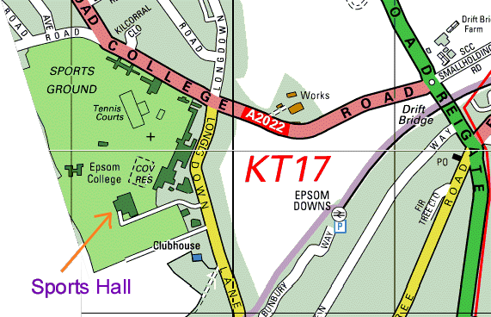
2. Report Times: Epee 9.30am, Sabre 1pm. (Please note that this is a “close of reporting” time).
3. BFA* Cards: You must have your BFA card with you. This is vital for your entry to the BYC Finals.
4. BYC⁺Finals: A minimum of four fencers in each event qualify for the British Youth Championships finals. I recommend that you read the BYC finals rules. It is expected that these will be available via the BFA website but meanwhile a copy is available on the SCFU website. Note that to claim a bye you must enter this qualifier AND inform the organiser of this qualifier that you are claiming your bye (you do not have to fence). Unclaimed byes may be forfeited.
5. If you need paper details for the BYC finals then please request them from the organiser of this event.
6. Referees: We will rely on clubs bringing referees. If coaches are reserved for coaching / chaperoning then please bring additional referees. Unless enough referees from clubs can volunteer, you will be asked to referee each other.
7. Kit: Please note all events will be electric. You must bring your kit in good working order and in a safe condition. The organiser reserves the right to refuse to allow a fencer to compete in kit he considers to be unsafe. Plastrons and breeches are mandatory.
8. Blade size 2 required for U14 epee and sabre. Blade size 5 acceptable for U16/U18.
9. Disclaimer: All fencers are reminded that they compete at their own risk. The organisers will take all reasonable care, but do not accept liability for loss or injury, howsoever caused. A parent or guardian must sign the entry form. If you object to photography then consult the organiser.
10. Any changes or announcements will be posted at www.scfu.homestead.com
11. Your entry fee does include a levy towards the National final but qualifiers also have to pay an additional fee to compete in that final. Your entry fee does not include cleaning of the sports hall; we are relying on no one spilling any food or drink.
12. Boxes (central judging apparatus): We may rely on clubs bringing boxes. Please let the organiser know how many boxes your club can send.

I hope we will have a great day of fencing and that many South East fencers will qualify for the BYC Finals on 19th-20th February 2005 (see BFA or SCFU Web site for details).

Yours,
Ian de Whalley on behalf of Keith Smith
SCFU Secretary Competition Organiser
*BFA=British Fencing Association. ⁺BYC=British Youth Championships.

Entry Form

Please print clearly:
1. Name ………………………………………….……………….…..………...……….
2. Male / Female (delete as applicable).
3. Club ………………………………………………………….….……….….………
4. Email (optional) ……………………………………………………….………….…….…..
5. Address (needed for BYC finals forms)………………………………….…………….………..….
…………………………………………………………..………….….………
6. Phone 1 (only if no email) ……………………………………………...……….………….
7. Phone 2 (on the day emergency number) ……………………….………..……………..….
8. BFA Membership Number. ………………… Expires ………..………………………
9. Date of birth ………………………………
The age dateline is 1st Jan 2006. For example, if you were born in 1992 or 1993 then you will fence in the U14 group. If you were born in 1988 or 1989 then you will fence in the U18 group.
10. U14 / U16 / U18 (delete as applicable). Epee / Sabre (you may enter both if you wish)
11. Seeding Information. Please state your previous best results. List best results first. If this is your first competition then please state for how long you have been fencing.

Year | Event | Position

12. Signature of parent /guardian …………………………………..…………..
13. Payment: Cheque for £10 per event, payable “S.C.F.U.”
14. Please post to:
Mr. Keith Smith, Whitgift School, Haling Park, South Croydon, CR2 6YT
Thank you for your entry to this competition. If you require confirmation of entry then please include a self addressed and stamped postcard (and preferably enter a legible email address above).

