

Surrey Fencing

Barwell 2005

1. Date: Sunday 11th December 2005
2. Venue: Sports Hall, Epsom College, Longdown Lane, Epsom, KT17 4JQ.
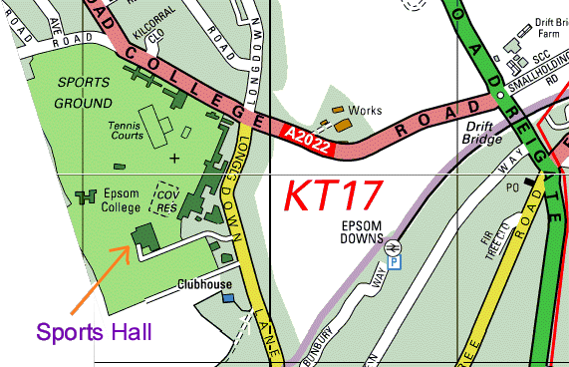

3. Start Time: 9.00am check-in.
4. Entry Fee: £32 per team of four. Cheques payable to “Surrey County Fencing Union”.
5. Entries to: Susan Grove, 24 Jasmin Rd, W Ewell, Surrey, KT19 9DZ.
Enclose SAE if you require confirmation of entry.
6. Each team consists of one of each: ladies foil, mens foil, epee and sabre.
7. Each member of the winning team will receive a trophy.
The winning team will receive a cash prize of £30 .
8. Separate trophies will be awarded to individuals in each weapons.
9. All fencers must be age 13 years or over before 1st January in the season of the event. The season funs from 1st September to 31st August.
10. All fencers must participate in accordance with BFA Safety Guidelines (see BFA website).
11. It is anticipated that the event will end by 2pm (in time for a pub lunch)
12. Any changes or announcements will be posted at www.scfu.homestead.com.



SCFU Entry Form –Barwell 2005

Club / Name of Team: ___________________________________________

Name of team captain / contact _____________________________________

Address: ______________________________________________________

______________________________________________________

______________________________________________________

Tel No: _________________________________________

e-mail: _____________________________________________________ (for confirmations and future fixture information)

Entry Fee: £32 per team Cheques payable to “Surrey County Fencing Union”.
SAE please if you require confirmation of entry.

Entries to: Susan Grove, 24 Jasmin Rd, W Ewell, Surrey, KT19 9DZ.
Issue C, 5th March 2006. See www.scfu.homestead.com for latest. Page 1 of 1

