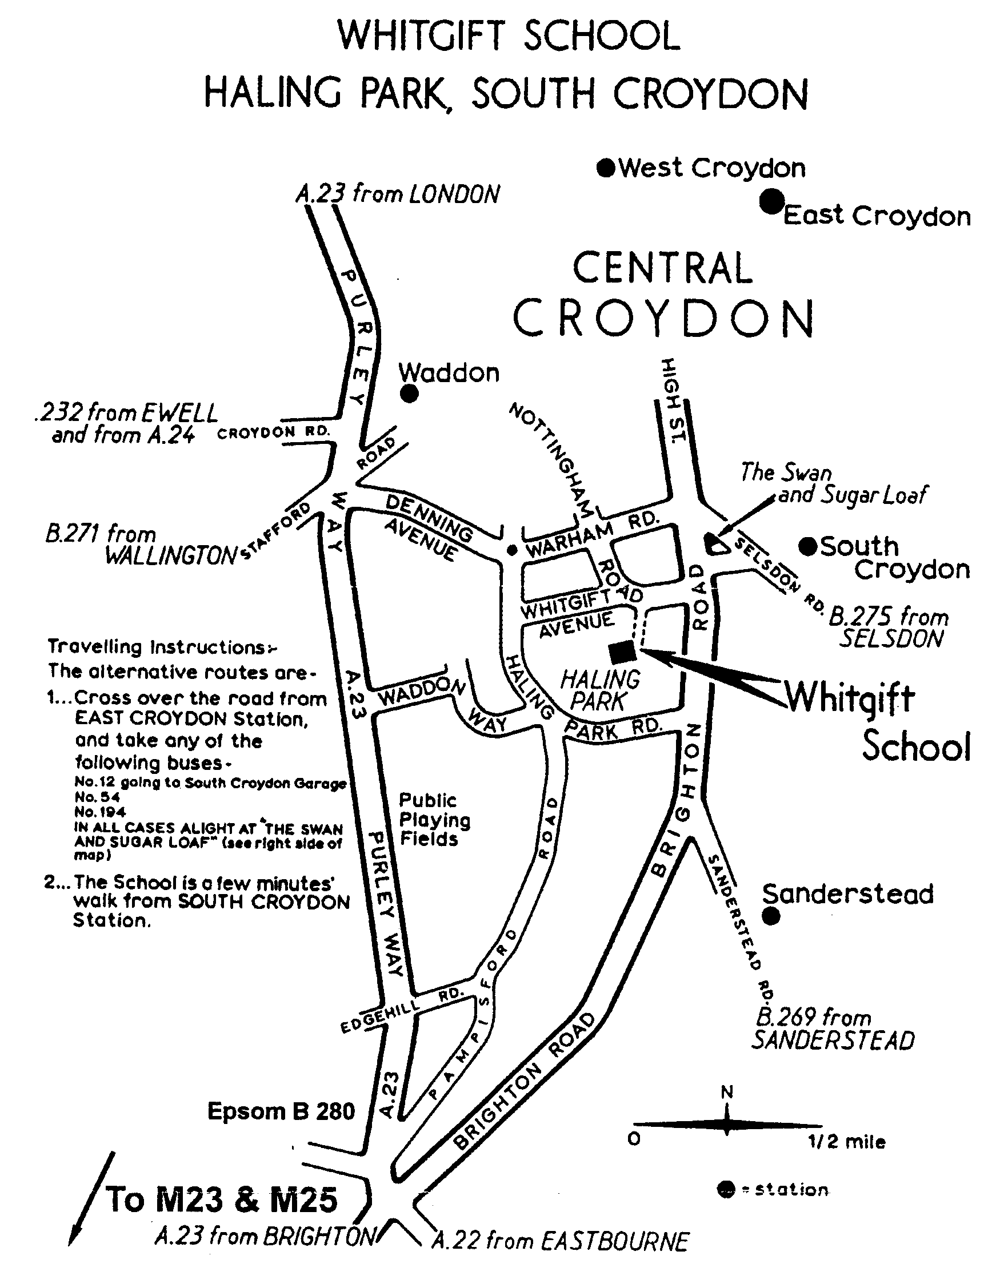
- Venue: Sports Hall, Whitgift School,
Haling Park, Croydon, CR2 6YT

2. Report By Times:
U14 U16 U18 Foil 9.00am
U10 U12 Foil 9.45am
U12 U14 U16 U18 Epee 1.00pm
U12 U14 U16 U18 Sabre 2.30pm

The organiser may combine some categories

Start times will depend on boxes and referees.

3. BFA Cards: Bring your British Fencing Association
membership card with you.

4. Please note all foil and epee events will be electric.
Sabre will be electric wherever possible.
5. Referees: If your club can bring a referee, this will help the smooth running of the competition. If clubs wish to reserve a coach for coaching / supervising then please bring additional referees as well. If there are not enough referees then fencers may be asked to referee each other.
6. Electric apparatus: Would clubs please send a box if possible (we will rely on this, please notify organiser how many sets you can bring).
7. Kit: You must bring your kit in good working order and in a safe condition. The organiser reserves the right to refuse to allow a fencer to compete in kit he considers to be unsafe. Plastrons are mandatory. Breeches are recommended but safe trousers (pockets closed/taped/sewn) for U10, U12 and U14 may be allowed at organisers discretion.
8. U18=born in 1989 or 90. U16=born in 1991 or 92; U14=born in 1993 or 94; U12=born in 1995 or 96 or 97 only except foil where U12F=1995/96 and U10F=1997/98 only.
9. Blade size restrictions: U10Foil any size 0-3, U12 and U14: Foil any size 0-3, sabre 0-2, epee 0-2 only. U16 & U18 may use any size 0-5. Note that the U10 rule is different to the BYC U10 rule (size 0 only).
10. Please do bring your own provisions but do not consume or spill sticky drinks in the sports hall. Your entry fee does not include cleaning of the sports hall; we are relying on no one spilling any food or drink. The swimming pool may be used.
11. Disclaimer: All fencers are reminded that they compete at their own risk. The organisers will take all reasonable care, but do not accept liability for loss or injury, howsoever caused. A parent or guardian must sign the entry form. If you object to photography then consult the organiser before check-in.
12. Any changes or announcements will be posted at www.SurreyFencing.com

I hope we will have a great day of fencing.
Yours,
Ian de Whalley on behalf of Jim Hamilton
SCFU Secretary Competition Organiser
Entry Form
Please print clearly:
1. Name ………………………………………….……………….……..……...……….
2. Male / Female (delete as applicable).
3. Foil / Epee / Sabre (delete as applicable). You may enter 1, 2 or 3 weapons but if you are still fencing in one when your next is ready to start then we may cancel & refund your entry.
4. Club …………………………………………………………….….…….….………
5. Email …….………………………………………………….………….….…….…..
6. Address …………………..……………………………….……….………………..….
………………………………………………………….…….…….….………
7. Phone 1 .……………………………...……………………….……………..………….
8. Phone 2 (on the day emergency number) ……………………….……………………...…..….
9. BFA Membership Number. ………………… Expires ……………..…………………
10. Date of birth ………………………………
U18=born in 1989 or 90. U16=born in 1991 or 92; U14=born in 1993 or 94; U12=born in 1995 or 96 or 97 only except foil where U12F=1995/96 and U10F=1997/98 only.
11. U10 (foil only)/U12 / U14 / U16 / U18
12. Seeding Information. Please state your previous best results. List best results first. If this is your first competition then please state for how long you have been fencing. State any cadet / junior / senior national ranking.
Year | Event & weapon | Position/Rank

13. Signature of parent /guardian ……………………………(if parent/guardian will not be staying with the fencer then please assign a responsible adult).
14. Payment: Cheque for £7.00/event payable “S.C.F.U.”
Please post to: James Hamilton, 15 Chivenor Grove, Kingston upon Thames, Surrey, KT2 5GE Tel: 020 8549 6764, email: ***redacted** for this event only .
If you have entered a legible email address above (or enclosed a self addresses and stamped postcard / envelope) then your entry will be confirmed on receipt.
Thank you for your entry to this competition.

