30/09/2006 Sussex Open – Sat. Epée & Sun. Foil

Entries to: Mrs E Pitman, 5 Penn Crescent, Ringmer, Lewes, East Sussex BN8 5HQ
Tel: 0l27 381 2598
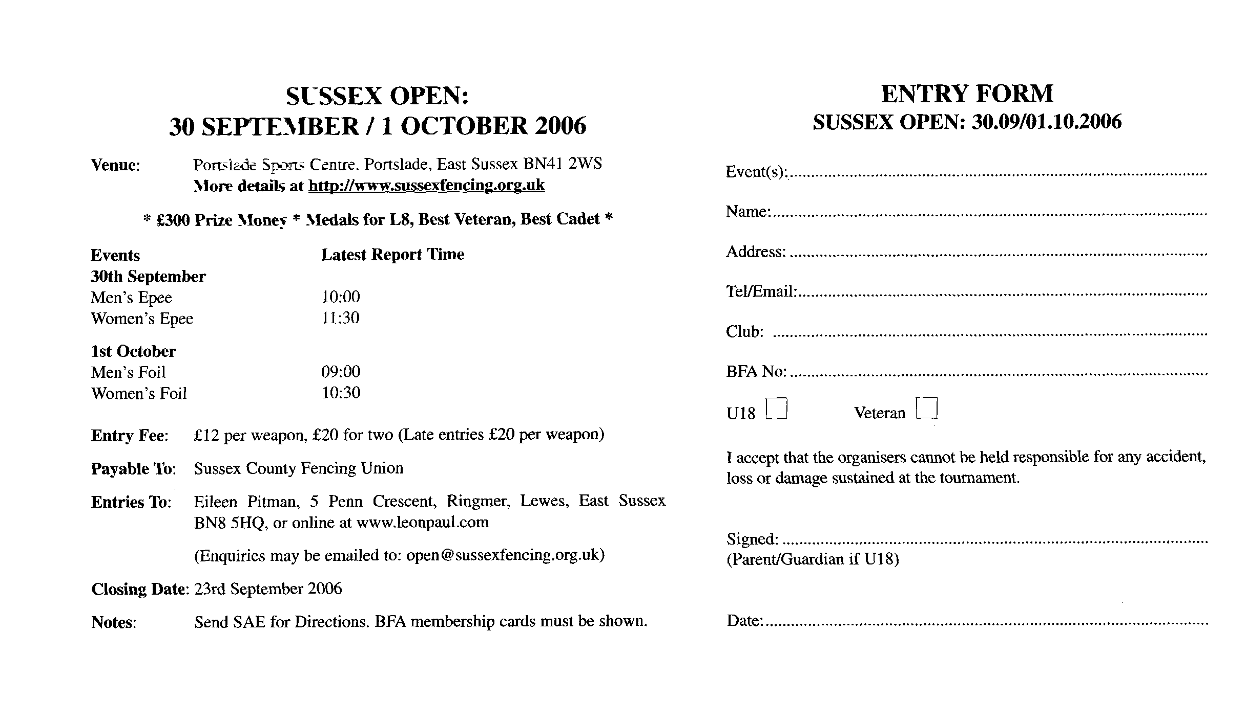

Official details are at www.BritishFencing.com but at time of writing (2Sept2006), on www.sussexfencing.org.uk website I only found links to details for the 2005 event and I did not find this event listed on www.leonpaul.com’s shop website.

