Dear Fencer,
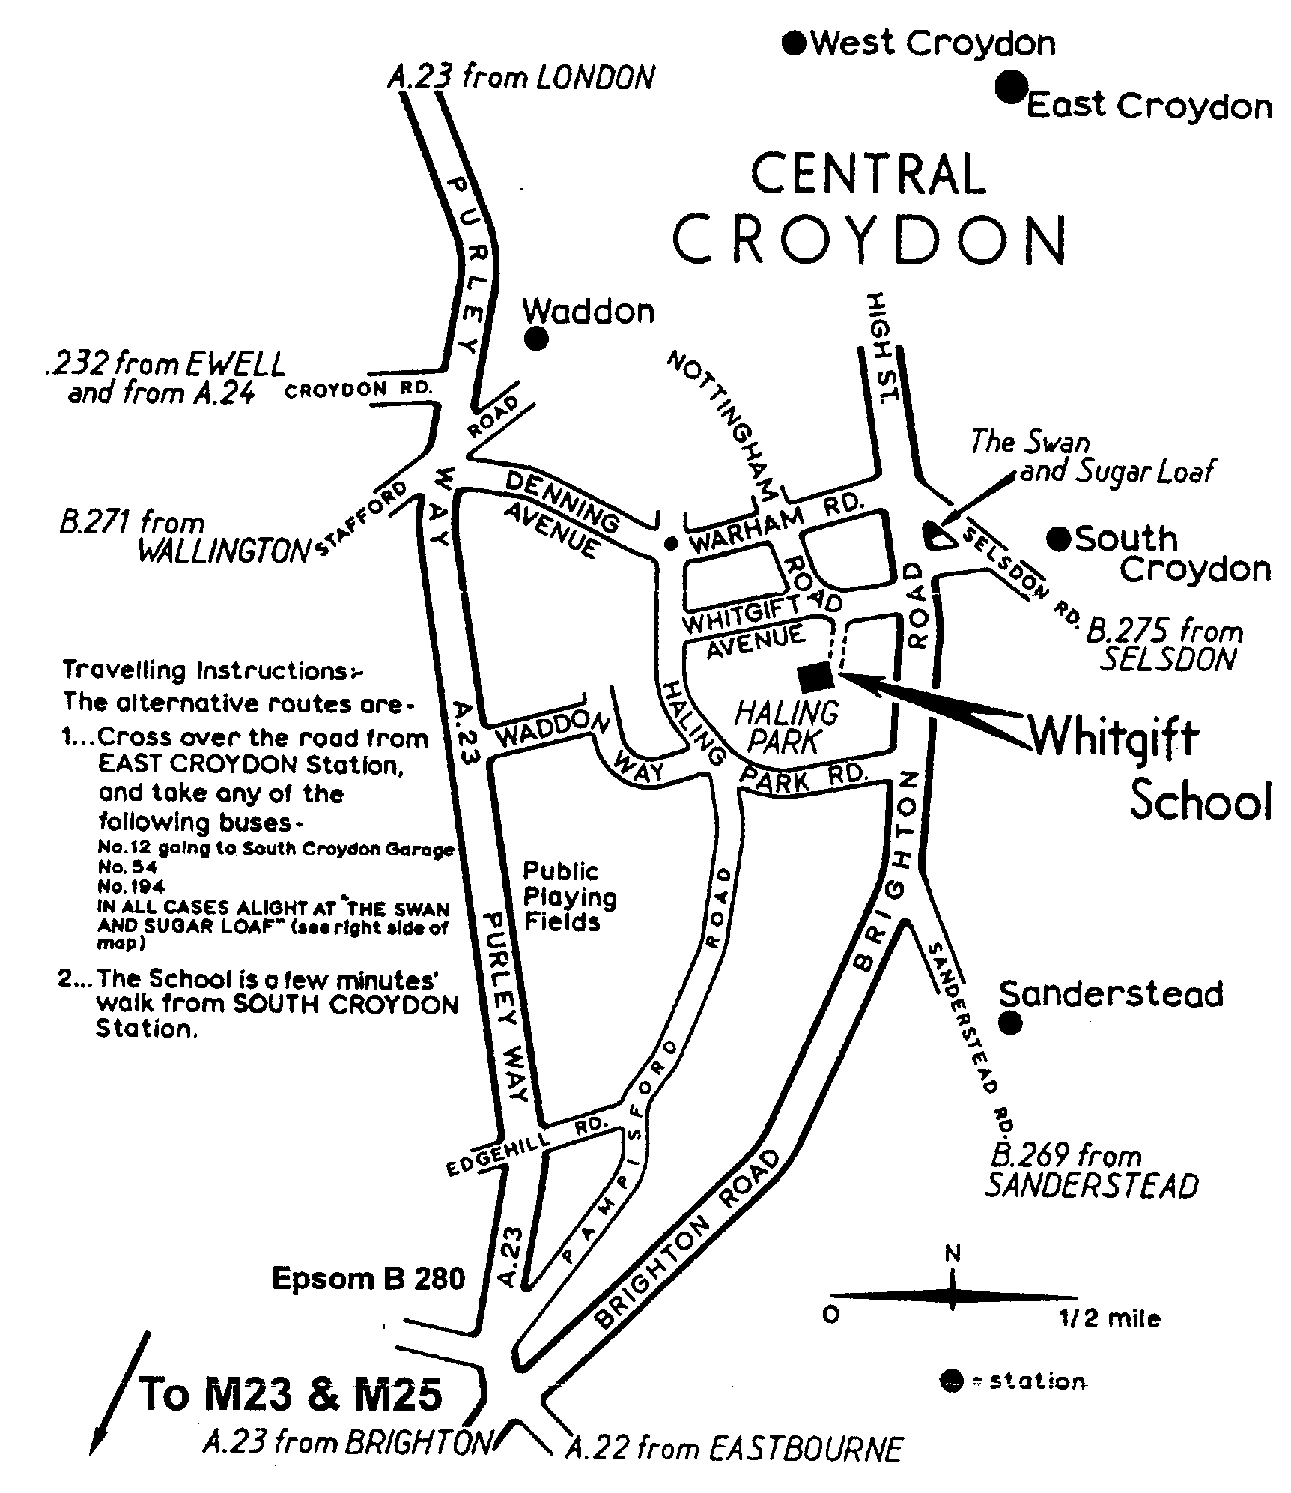

These details and entry form are long because this has
been found necessary for this event.
Please do read on and complete the entry form.

1. Venue: Sports Hall, Whitgift School,
Haling Park, Croydon, CR2 6YT.

2. Report Times: U14 by 9.30, U12 by 10.30.
(Start times will depend on referees and boxes).

3. BFA* Cards: You must have your BFA card with you.
This is vital for your entry to the BYC Finals.
4. BYC⁺Finals: A minimum of four fencers in each event qualify for the British Youth Championships finals. I recommend that you read the BYC finals rules. It is expected that these will be available via the BFA website but meanwhile a copy is available on the SCFU website. Note that to claim a bye you must enter this qualifier AND inform the organiser of this qualifier that you are claiming your bye (you do not have to fence). Unclaimed byes may be forfeited.
5. If you need paper details for the BYC finals then please request them from the organisers of this event.
6. Referees: We are likely to be short of adult referees for this event (due to clash with Leicester Open and other events). If your club can bring a referee, this will help the smooth running of the competition. If clubs wish to reserve a coach for coaching / supervising then please bring additional referees as well. Would U14 fencers capable of refereeing please referee U12 pools on request. U14 fencers may have to referee each other.
7. Electric apparatus: Would clubs please send a box if possible (We may rely on this. Please notify organiser how many sets you can bring).
8. Kit: Please note all events will be electric. You must bring your kit in good working order and in a safe condition. The organiser reserves the right to refuse to allow a fencer to compete in kit he considers to be unsafe. Blades must be size 3 or smaller. Plastrons are mandatory. Breeches are recommended but for this event safe trousers with closed pockets may be allowed at organisers discretion.
9. Disclaimer: All fencers are reminded that they compete at their own risk. The organisers will take all reasonable care, but do not accept liability for loss or injury, howsoever caused. A parent or guardian must sign the entry form. If you object to photography then consult the organiser before check-in.
10. Any changes or announcements will be posted at www.SurreyFencing.com
11. You may use the swimming pool. Your entry fee does not include cleaning of the sports hall; we are relying on no one spilling any food or drink. Please keep the floor clean.
12. You may only enter one regions’ qualifier for each BYC event. If you live and fence in multiple regions then only enter a category (eg U14B foil) once per season.

I hope we will have a great day of fencing and that many South East fencers will qualify for the BYC Finals on 20th-21st January 2007 (see BFA or SCFU Web site for details).

Yours,
Ian de Whalley on behalf of Tim Schofield
SCFU Secretary Competition Organiser

*BFA=British Fencing Association. ⁺BYC=British Youth Championships.

Entry Form

Please print clearly:
1. Name ………………………………………….……………….…………...……….
2. Male / Female (delete as applicable).
3. Club …………………………………………………………….……….….………
4. Email …………………..……………………………………….………….…….…..
5. Address (for BYC finals forms) …………………………………………….……….………..….
………………………………………………………….………….….………
6. Phone 1 …………….…..………………………………………….……….………….
7. Phone 2 (on the day emergency number) ……………………….………………..….
8. BFA Membership Number. ………………… Expires ………………………………
9. Date of birth ………………………………
Born (1997,) 1998 or 1999: See BFA fixture list if you wish to enter U10 final directly.
Born 1997: Choose either U10 (enter BYC final directly) or U12 (via this qualifier).
Born 1995, 1996 (or 1997): Enter the U12 age group.
Born 1993 or 1994: Enter the U14 age group only.
Born 1989 to 1992: See Surrey fixture list for details of U16 and U18 qualifiers.
10. U12 / U14 (delete as applicable).
11. Seeding Information. Please state your previous best results. List best results first.
If this is your first competition then please state for how long you have been fencing. State any cadet / junior / senior national ranking.
Year | Event | Position / Rank
12. Signature of parent /guardian …………………….…………
If parent/guardian will not be staying with the fencer then please assign a responsible adult.
13. Payment: Cheque for £12, payable “S.C.F.U.” (includes levy for BYC finals).
14. Please post to:
Tim Schofield, 3 Oaktree Close, Guildford, Surrey, GU4 7JQ.
If you have entered an email address (or enclosed an s.a.e.) then I will confirm your entry. Thank you for your entry to this competition.

