Dear Fencer,
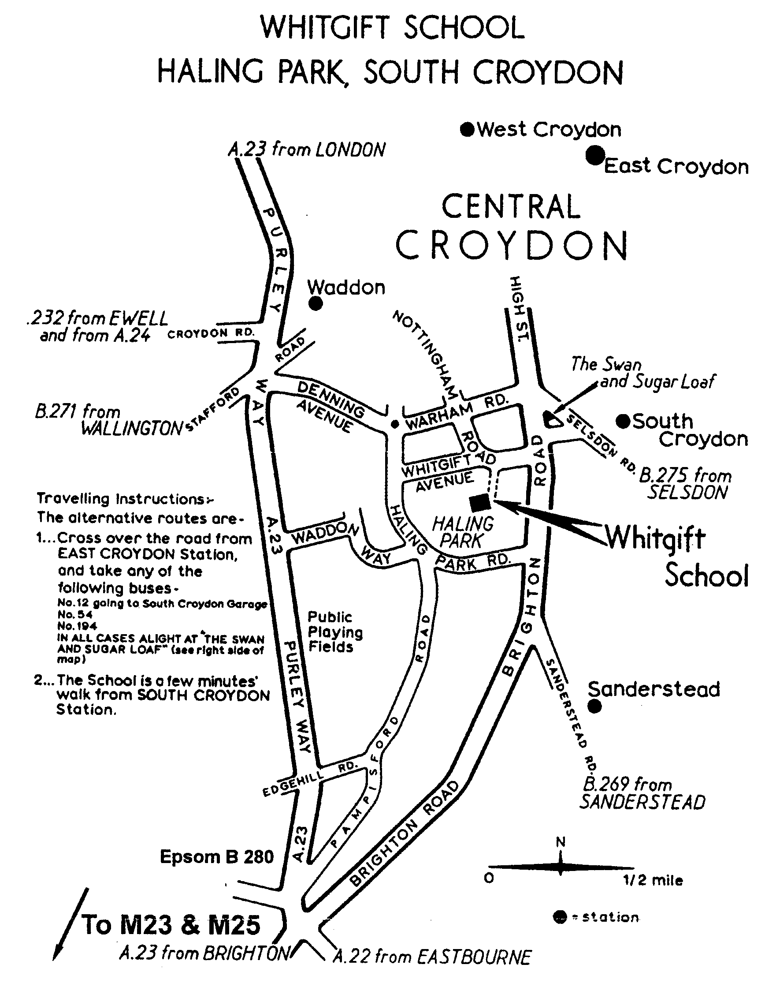

These details and entry form are long because
this has been found necessary for this event.
Please do read on and complete the entry form.

1. Venue: Sports Hall, Whitgift School,
Haling Park, Croydon, CR2 6YT

2. Report Times: Epee 9.30am, Sabre 1pm.
(Please note that this is a “close of reporting” time).

3. BFA* Cards: You must have your BFA card with you.
This is vital for your entry to the BYC Finals.

4. BYC⁺Finals: A minimum of four fencers in each event qualify for the British Youth Championships finals. I recommend that you read the BYC finals rules. It is expected that these will be available via the BFA website but meanwhile a copy is available on the SCFU website. Note that to claim a bye you must enter this qualifier AND inform the organiser of this qualifier that you are claiming your bye (you do not have to fence). Unclaimed byes may be forfeited.
5. If you need paper details for the BYC finals then please request them from the organiser of this event.
6. Referees: We will rely on clubs bringing referees. If coaches are reserved for coaching / chaperoning then please bring additional referees. Unless enough referees from clubs can volunteer, you will be asked to referee each other.
7. Kit: Please note all events will be electric. You must bring your kit in good working order and in a safe condition. The organiser reserves the right to refuse to allow a fencer to compete in kit he considers to be unsafe. Plastrons are mandatory. Breeches are mandatory for U16 & U18. Pockets must be closed.
8. Blade size 2 required for U12 and U14 (epee and sabre). Blade size 5 acceptable for U16 and U18.
9. Disclaimer: All fencers are reminded that they compete at their own risk. The organisers will take all reasonable care, but do not accept liability for loss or injury, howsoever caused. A parent or guardian must sign the entry form. If you object to photography then consult the organiser.
10. Any changes or announcements will be posted at www.SurreyFencing.com
11. You may use the swimming pool. Your entry fee does not include cleaning of the sports hall; we are relying on no one spilling any food or drink. Please keep the floor clean.
12. Boxes (central judging apparatus): We may rely on clubs bringing boxes. Please let the organiser know how many boxes your club can send.
13. You may only enter one regions’ qualifier for each BYC event. If you live and fence in multiple regions then only enter a category (eg U14B epee) once per season.

I hope we will have a great day of fencing and that many South East fencers will qualify for the BYC Finals on 17th-18th February 2007 (see BFA or SCFU Web site for details).

Yours,
Ian de Whalley on behalf of Keith Smith
SCFU Secretary Competition Organiser
*BFA=British Fencing Association. ⁺BYC=British Youth Championships. SCFU=Surrey County Fencing Union.

Entry Form

Please print clearly:
1. Name ………………………………………….……………….…..………...……….
2. Male / Female (delete as applicable).
3. Club ………………………………………………………….….……….….………
4. Email ……..…………………………………………………….………….…….…..
5. Address (needed for BYC finals forms)………………………………….…………….………..….
…………………………………………………………..………….….………
6. Phone 1 …………………………….……………………………...……….………….
7. Phone 2 (on the day emergency number) ……………………….………..……………..….
8. BFA Membership Number. ………………… Expires ………..………………………
9. Date of birth ………………………………
The age dateline is 1st Jan 2007. U12=born in 1995 or 1996 or 1997 only;
U14=born in 1993 or 1994; U16=born in 1991 or 1992; U18=born in 1989 or 1990.
10. U12 / U14 / U16 / U18 (delete as applicable).
11. Epee / Sabre (you may enter both if you wish)
12. Seeding Information. Please state your previous best results. List best results first. If this is your first competition then please state for how long you have been fencing. State any cadet / junior / senior national ranking.
Year | Event | Position / Rank

13. Signature of parent /guardian ……………………………
(if parent/guardian will not be staying with the fencer then please assign a responsible adult).
14. Payment: Cheque for £12 per event, payable “S.C.F.U.” (Includes levy for BYC finals)
15. Please post to:
Mr. Keith Smith, Whitgift School, Haling Park, South Croydon, CR2 6YT
Thank you for your entry to this competition. If you require confirmation of entry then please include either a legible email address above or a self addressed and stamped postcard (or envelope).

