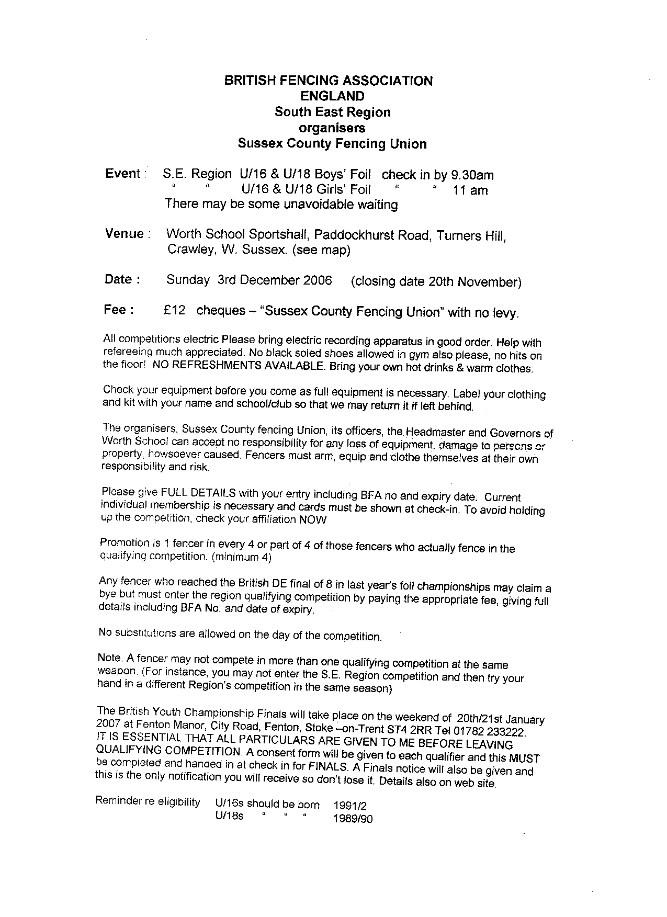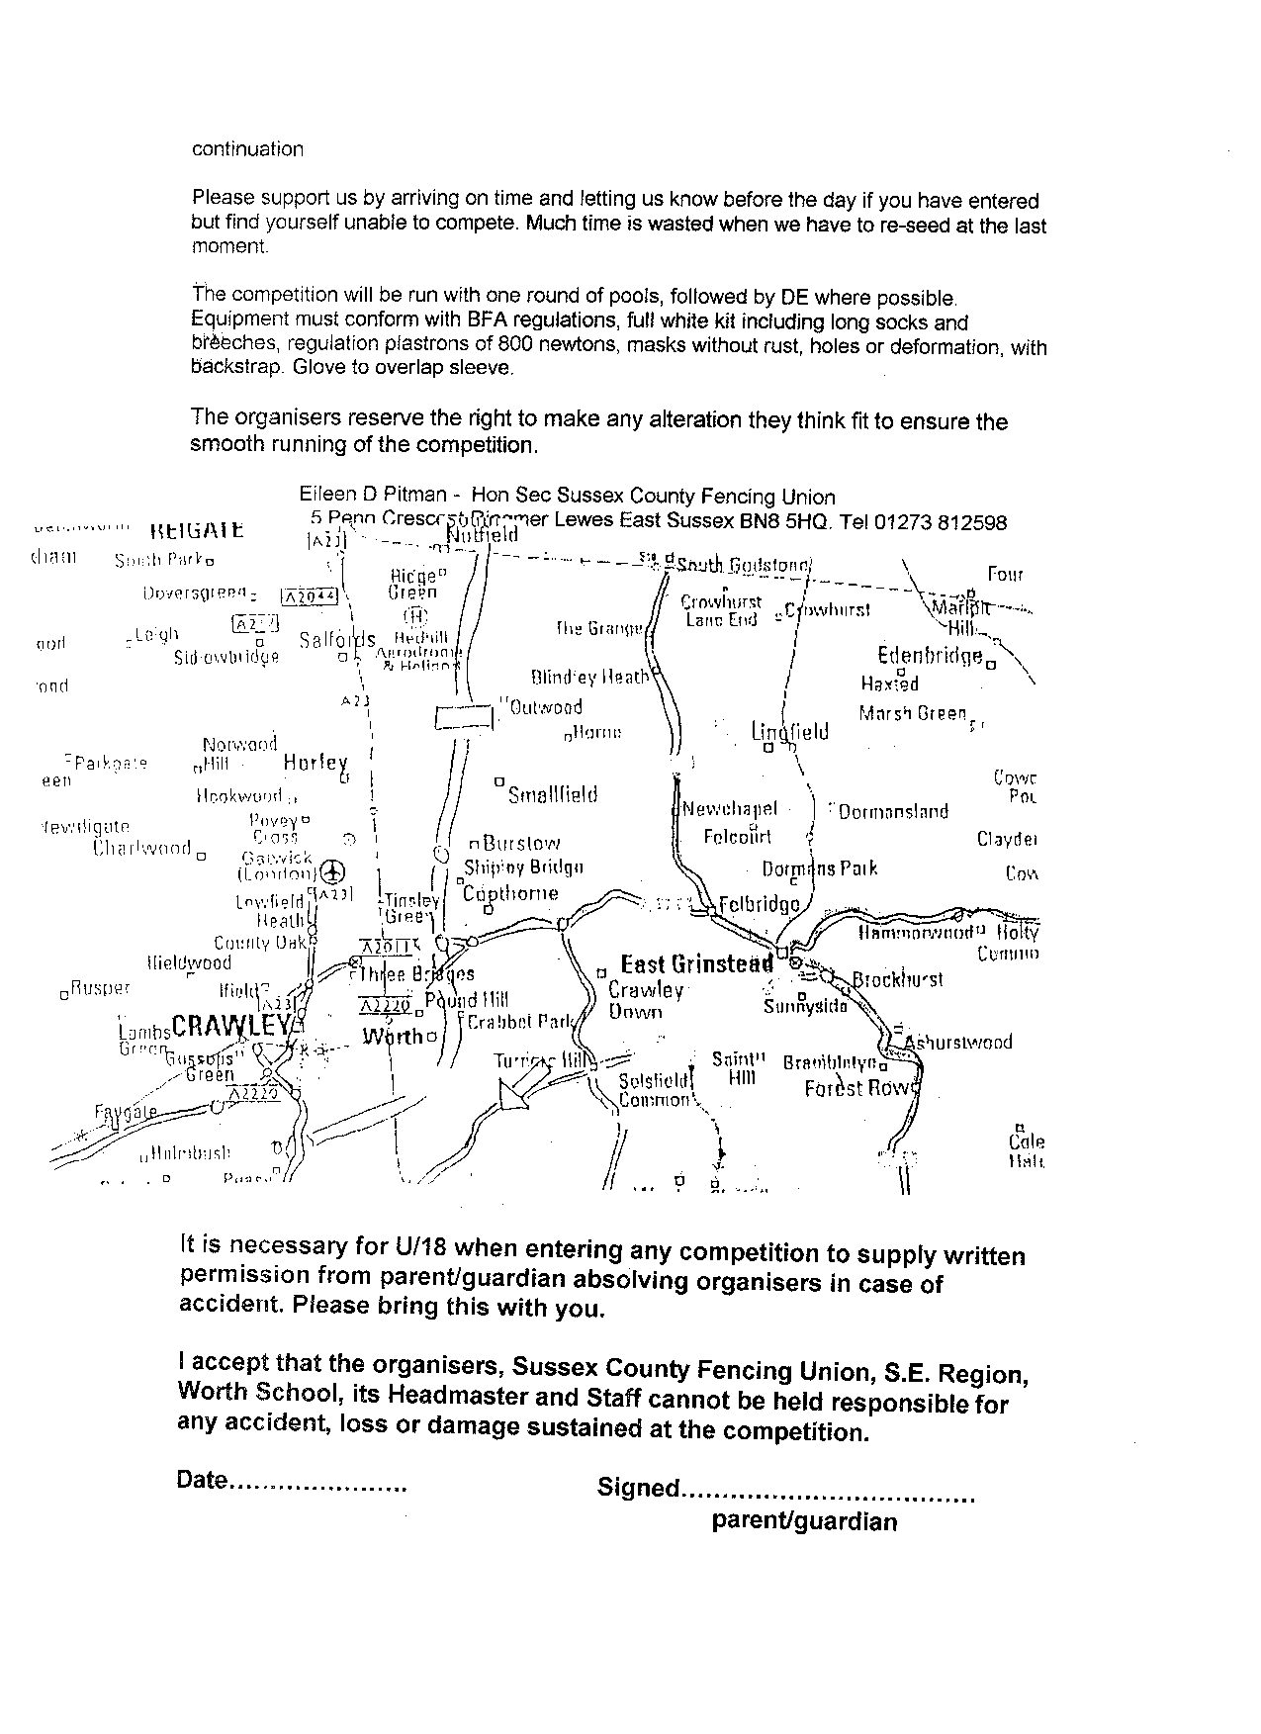
Entries to: Mrs E Pitman, 5 Penn Crescent, Ringmer, Lewes, East Sussex BN8 5HQ
Tel: 0l27 381 2598

