- Venue: Dulwich College Sports Club, Pond Cottages, opposite Dulwich College, Dulwich SE21 7LD.
(Venue booking 8.30 – 5.30). Please park in College Road or the main college car park; NOT in the PE Centre car park.
The Sports Centre is on the opposite side of College Road to Dulwich College
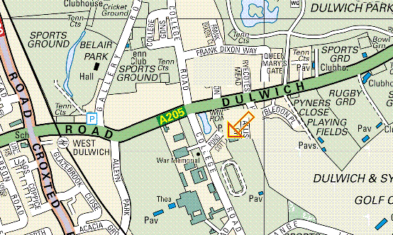
- Report By Times:
Novice Foil: Men 9:00, Women 9:30
Novice Epee, Men 10:15, Women 10:30
Intermediate Foil, Men 12:00 Women 12:15
Intermediate Epee: Men 12:30, Women 12:30
- BFA Cards: Membership of the British Fencing Association is a condition of entry. Bring your card with you and show it at check-in. Social members please carefully read the sentence marked ⁪ near the entry form signature.
- Novices Eligibility: Open to those with 0, 1, 2 or 3 (but not more) years aggregate fencing experience, living or fencing in Surrey (which includes London south of the river and west of Ravensbourne River). Out of area fencers may contact the organiser re. competing without being included in the results/medals.
- Intermediates Eligibility: Not open to those who have achieved a top three placing in any county or region event or top 16 placing in any national event. At organisers discretion. Please send details with entry. Open to those eligible and living or fencing in Surrey, which includes London south of the river and west of Ravensbourne River. Out of area fencers may contact the organiser re. competing without being included in the results/medals.
- Separate womens competitions will be held if sufficient numbers enter, else men’s & womens events will be combined (in which case separate trophies would be awarded to the highest placed women).
- All fencers must be age 13 years or over before 1st January in the season of the event. The season runs from 1st September to 31st August.
- All fencers must participate in accordance with BFA Safety Guidelines (see BFA website).
- Kit: You must bring your kit in good working order and in a safe condition. The organiser reserves the right to refuse to allow a fencer to compete in kit he considers to be unsafe. Plastrons are mandatory, per BFA rules.
- Referee: If your club can bring a referee, this will help the smooth running of the competition.
- You may enter the SCFU Intermediates as well as Novices at the same weapon at the discounted rate of only £5 extra but the organiser reserves the option to exclude from the Intermediates any Novices who are still fencing when the Intermediates starts (fee would be refunded).
- You may enter two events but you might not be allowed to compete in both. If you are still fencing in one when the second starts then your entry fee will be refunded.
- Please do bring you own provisions but do not consume or spill sticky drinks in the sports hall. Your entry fee does not include cleaning of the sports hall; we are relying on no one spilling any food or drink.
- Disclaimer: All fencers are reminded that they compete at their own risk. The organisers will take all reasonable care, but do not accept liability for loss or injury, howsoever caused. For Under 18 competitors a parent or guardian must sign the entry form. If you are under 18 and object to photography then consult the organiser.
- Any changes or announcements will be posted at www.SurreyFencing.com
- Last years results are at: http://www.guildfordfencing.co.uk/surreynovicesandintermediates2006.html

I hope we will have a great day of fencing.
Yours,
Ian de Whalley on behalf of Elaine Buzwell
SCFU Secretary Competition Organiser

Entry Form

(Please use a separate form for each individual / team).
Please print clearly:
1. Name ………………………………………….……………….……..……...……….
2. Male / Female (delete as applicable).
3. Novice Foil / Intermediate Foil / Novice Epee / Intermediate Epee (delete as applicable).
4. Club …………………………………………………………….….…….….………
5. Email (optional) …………………………………………………….………….….…….…..
6. Address (only needed if no email) ……………………………….……….………………..….
………………………………………………………….…….…….….………
7. Phone (only if no email) …….…………………………………….……………..………….
8. BFA Membership Number. ………………… Expires ……………..………(see also ⁪ below)
9. Date of birth (if under 18 on day of event) ………………………………
All fencers must be age 13 years or over before 1st January in the season of the event.
The season runs from 1st September to 31st August.
10. Individual seeding information. Please state your previous best results. List best results first. If this is your first competition then please state for how long you have been fencing.
Year | Event | Position
Competitors must ensure that all kit is of a safe and serviceable nature, and that BFA safety guidelines are met.
⁪ For BFA / England Fencing Social Members only: I confirm that this is my first and only competition using this social membership in this membership year.
I accept that the organisers cannot be held responsible for any accident, loss or damage sustained at the competition.
11. Signature (parent /guardian if under 18) .……………….……………..……..…Date…….……..
12. Payment: £12.00 for 1 event or £17 for 2 events. Cheque payable “S.C.F.U.”
On-the-day entries (i.e. not notified in advance): £20 per event.

Please post to Elaine Buzwell, 11 Beaconsfield Place, Epsom, Surrey, KT17 4BD.

If you require confirmation of entry and have not given an email then please include an sae.
Thank you for your entry to this competition.

