

Wimbledon Fencing Club

Wimbledon Invitation Challenge Competition

Wimbledon Fencing Club will be holding the annual Invitation Challenge Competition on Sunday 15th April 2007 at Ursuline High School from 10.00am to 4.00pm.

The event consists of eight teams of eight fencers, composed of two male foilists, two female foilists, two epeeists and two sabreurs.

The competition consists of two rounds. Round one is a seeding round, the top four enter pool 1 and the lowest four enter pool 2 for the second round. In round two fencers are awarded scores for their final position, 16 for the highest and 1 for the lowest. Each club’s scores are added together for the final result. It gives a full day’s fencing for all fencers.

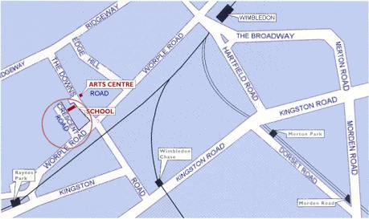
Date: Sunday 15th April 2007

Venue: Ursuline High School

Merci Sports Centre

The Downs

(off Worple Road)

London SW20 8HA

Time: Check in at 10.00am for a 10.30am start, the event should finish by 4.00pm.

Refreshments will be available ! (Lunch snacks and refreshments)

Note : The fee will be £40 per team. (Cheques made payable to Wimbledon Fencing Club). The first seven entries received with Payment will be entered. This event can only be run if the entry is sufficient to make it financially viable, so please return your entries as soon as possible to:

Teresa Miarka
53 Kenilworth Avenue teresamiarka@yahoo.co.uk
London SW19 7LP
0208 947 2617 07719664303

BFA membership required

---------------------------------------------------------------------------------------------------------------------------------

We________________Fencing Club will / will not be entering the Wimbledon Invitation Competition

We will / will not be able to bring an electric box to the competition

We will / will not be able to bring a President in the following weapons: _____________________

I accept that the organisers cannot be held responsible for any accident, loss or damage sustained at the competition. Competitors must ensure that all kit is of a safe and serviceable nature, and that BFA safety guidelines are met.

Signed: _______________________________ Date: __________________________

