Surrey Youth Games,

Click here for further information

http://www.activesurrey.com/content-2120

Sunday 24th June 2007

Guildford High School

U14 epee team, 3 x girls or 3 x boys

To be considered for a team please get in touch with the team manager for your area:
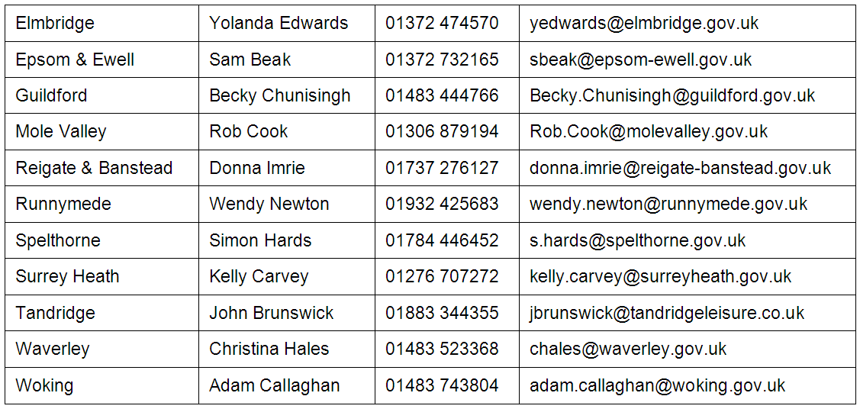

Safe equipment per BFA recommendations (incl. breeches) will be required.

Overall event co-ordinator is:
Linda Jacks
Events Officer
Active Surrey Sports Partnership
01483 518959

Organisation of the Fencing Competition will be supported by Surrey County Fencing Union.

Issue A, 2nd March 2007 See www.SurreyFencing.com for latest

