

Surrey Fencing

Barwell 2007

- Date: Sunday 9th December 2007. 9.00am check-in
- Venue: Tooting Graveney School, Welham Road, Tooting, SW17 9BU (1.2km ESE from Tooting Broadway Tube). Sports Hall is to the South of Welham Rd, behind the lower school.
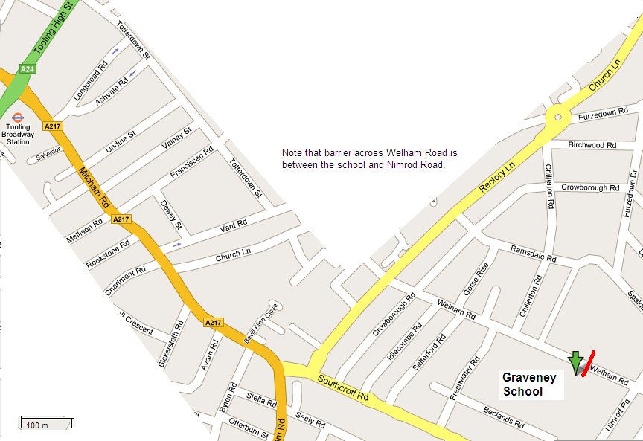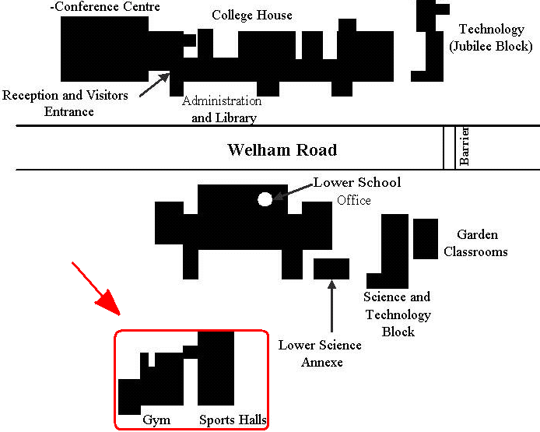
N

3. Each team consists of one of each: ladies foil, mens foil, epee and sabre.
4. Each member of the winning team will receive a trophy.
The winning team will receive a cash prize of £30 .
Separate trophies will be awarded to individuals in each weapon.
5. All fencers must be age 13 years or over before 1st January in the season of the event. The season funs from 1st September to 31st August.
6. All fencers must participate in accordance with BFA Safety Guidelines (see BFA website).
7. It is anticipated that the event will end by 2pm (in time for those choosing a pub lunch!)
8. Any changes or announcements will be posted at www.SurreyFencing.com.


SCFU Entry Form –Barwell 2007

Club / Name of Team: ___________________________________________

Name of team captain / contact _____________________________________

Address: ______________________________________________________

______________________________________________________

______________________________________________________

Tel No: _________________________________________

e-mail: _____________________________________________________ (for confirmations and future fixture information)

Entry Fee: £36 per team Cheques payable to “Surrey County Fencing Union” (or just SCFU).
Entries to: Elaine Buzwell, 11 Beaconsfield Place, Epsom, Surrey, KT17 4BD.
SAE or clearly written email address please if you require confirmation of entry.

Issue A, 16th October 2007. See www.SurreyFencing.com for latest. Page 1 of 1.

