1. Venue: Sports Hall, Belmont Prep School, Feldemore,
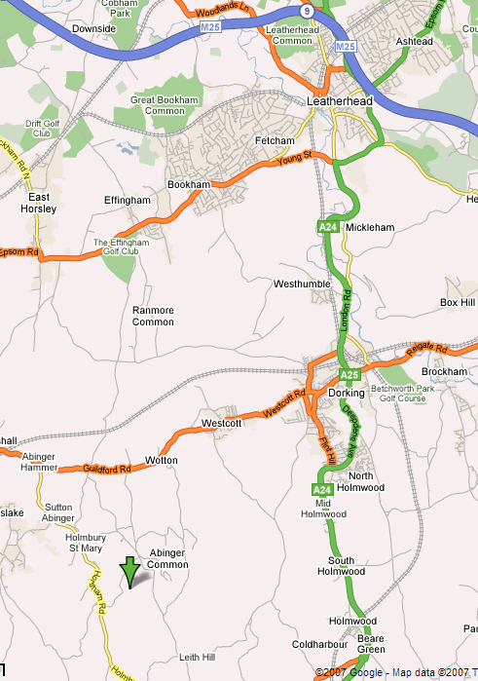
Holmbury St Mary, RH5 6LQ
(proper map recommended but see also pp3-4)

2. Report By Times (these are “close of report” times –no late
arrivals will be accomodated once pool sheets have been printed):-
Ladies Epee Individual 9.00am
Mens Epee Individual 9.15am
Ladies Sabre Individual 11.00am
Mens Sabre Individual 11.15am
[Note: Ladies & Men’s events may be merged if insufficient numbers.]

Epee Team (Mixed) 1.15pm
Sabre Team (Mixed) 2.00pm

3. BFA* Cards: BFA Cards:
Bring your British Fencing Association
membership card with you and show it at
check-in. Note that this includes team members.
4. Teams are of three fencers (with optional 4th reserve). You may substitute a reserve during a match if you wish provided they were nominated (record on pool sheet) before the match starts. If there is sufficient interest in advance for a separate ladies team event then that may be arranged.
5. Referee: If your club can bring a referee, this will help the smooth running of the competition.
6. Kit: You must bring your kit in good working order and in a safe condition. The organiser reserves the right to refuse to allow a fencer to compete in kit he considers to be unsafe. Plastrons are mandatory.
7. All fencers must be age 13 years or over before 1st January in the season of the event. The season runs from 1st September to 31st August.
8. All fencers must participate in accordance with BFA Safety Guidelines (see BFA website).
9. Blade size restrictions: N/A (size 5 weapons allowed)
10. Please do bring you own provisions but do not consume or spill sticky drinks in the sports hall. Your entry fee does not include cleaning of the sports hall; we are relying on no one spilling any food or drink.
11. Disclaimer: All fencers are reminded that they compete at their own risk. The organisers will take all reasonable care, but do not accept liability for loss or injury, howsoever caused. For Under 18 competitors a parent or guardian must sign the entry form. If you are under 18 and object to photography then consult the organiser.
12. It would help if clubs could provide electrical scoring equipment particularly for Sabre where new timeings apply (existing SCFU does not reflect the new timeings).
13. Any changes or announcements will be posted at www.SurreyFencing.com

I hope we will have a great day of fencing.
Yours,
Ian de Whalley on behalf of Neale Thomas
SCFU Secretary Competition Organiser

Entry Form

(Please use a separate form for each individual / team).
Please print clearly:
1. Name ………………………………………….……………….……..……...……….
2. Male / Female / Team (delete as applicable).
If your team is all female and you would like a separate event then tick here: ………………
(Note that this will depend on numbers entered)
3. Epee / Sabre (delete as applicable).
4. Club …………………………………………………………….….…….….………
5. Email …………………………………………………….………….….…….…..
6. Address (only needed if no email) ……………………………….……….………………..….
………………………………………………………….…….…….….………
7. Phone …….…………………..………………………...……….……………..………….
8. BFA Membership Number. ………………… Expires ……………..…………………
9. Date of birth (if under 18 on day of event) ………………………………
All fencers must be age 13 years or over before 1st January in the season of the event.
The season runs from 1st September to 31st August.
10. Individual seeding information. Please state your previous best results. List best results first. If this is your first competition then please state for how long you have been fencing.

Year | Event | Position

I accept that the organisers cannot be held responsible for any accident, loss or damage sustained at the competition. Competitors must ensure that all kit is of a safe and serviceable nature, and that BFA safety guidelines are met.
11. Signature (parent / guardian if under 18) .………………………..……..…Date…….……..
12. Payment: Cheque for £12.00/individual if paid in advance, £20/individual if paid on the day, £24/team payable to “S.C.F.U.” [payment date is the date the payment is received by the organiser].

Please post to: Neale Thomas, 8 Melvinshaw, Leatherhead, Surrey, KT22 8SX.
If you require confirmation of entry and have not given an email then please include an sae.
Thank you for your entry to this competition.

Nearest stations are Gomshall or Dorking (more trains). Arrange taxi before travelling (Gomshall is about 3miles from the venue along country lanes (i.e. walking not advised, consider a taxi from Dorking!).

Road Directions: Please bring a good map. Do not rely on these small extracts.
Heading west towards Guildford from Dorking on the A25, turn left along Hollow Lane approximately 0.5m after passing the Wotton Hatch Pub.

Heading east towards Dorking from Guildford, about 1.2m after passing through Abinger Hammer, turn right along Hollow Lane.

Follow Hollow Lane for about 1.4m. Then turn right along Pasture Wood Road. The school is about 0.6m along this road on the right hand side.

As you enter the school grounds, follow the drive round to the right. As you go down the hill there is a short gravel drive up to the left leading to the entrance to the sports centre. PLEASE DO NOT park here -this will be reserved for organisers bringing equipment in etc. There is plenty of car parking space just down the hill to the right, or just up the hill back toward the entrance on the right.

