SOUTH EAST REGION FENCING COMPETION
INTERMEDIATE MEN AND WOMEN’S FOIL
Sunday 13th November 2011

Venue: Worth College Sports Hall, Paddockhurst Road, Turners Hill, Crawley RH10 4SD
Competition entry information: This competition is open to fencers 13 and over on the day of the competition.
Competition licence: All competitors must have a valid national fencing licence, which will be checked on the day.
Parking: Free car parking is available at the venue for competitors and spectators, although space is limited.
Refreshments: There is no food available at the competition.
Equipment: In keeping with British Fencing regulations, a minimum of 350 Newton jacket, breeches and mask, and 800 Newton plastron are required. Anyone whose personal equipment fails to comply will not be able to fence.
Entry fee: £14
Payment: cheques made payable to ‘Sussex county fencing union’ and sent to: Brian Causton, Brightsands,Falmer Road, Rottingdean, East Sussex, BN2 7FQ
Email: Sussexfencing@gmail.com
Competition Website: www.sussexfencing.org.uk
Check-in times:
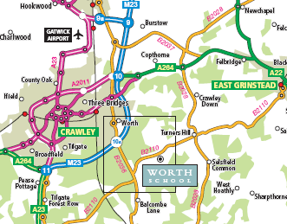
Check-in open 10.00am and closes 10.15am.
Location:

Entry Form
South East Region Intermediate Foil 2011
Please complete in capital letters

Name:

Address:

Post Code:

Tel. Number:

Email:

License No:

Club:

Competition (please delete as appropriate): MF WF

I enclose a cheque payable to ‘Sussex county fencing union’ for £

Signed

[If under 18 years of age, a parent or guardian must sign].

Date

