Surrey County Fencing Union

Barwell Cup 2013-2014


- Date: Sunday 8th December 2013 9.15am check-in
- Venue: Sports Hall, Wimbledon College, Edge Hill, SW19 4NS
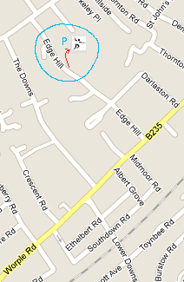
3. Each team is four fencers; one of each: ladies foil, mens foil, epee and sabre.
4. Each member of the winning team will receive a trophy.
Separate trophies will also be awarded to individual winners in each weapon.
5. All fencers must be age 13 years or over before 1st January in the season of the event.
The season runs from 1st September to 31st August.
6. All fencers must participate in accordance with BFA Safety Guidelines.
7. Foil mask bib lame required. Wire not essential if lame makes contact with jacket (ie inside tabs).
8. Any changes or announcements will be posted at www.SurreyFencing.com.


SCFU Entry Form –Barwell Cup 2013-2014

Club / Name of Team: ___________________________________________

Name of team captain / contact _____________________________________

Address: ______________________________________________________

______________________________________________________

______________________________________________________

Tel No: _________________________________________

e-mail: _____________________________________________________ (for confirmations and future fixture information)

Entry Fee: £24 per team. Cheques payable to “Surrey County Fencing Union”

Entries to: Jill Farmer, 0771 962 0441, e-mail. Payment on the day will be accepted-never too late to enter!
24 Wellington Road, London SW19 8EQ

SAE or clearly written email address please if you require confirmation of entry.

Issue B, 26th Nov 2013. See www.SurreyFencing.com for latest. Page 1 of 1.

